**Real Case Scenario**

**BitLocker Lockout Issue and Boot Device Security (BDS) on Windows**

Sebastian is experiencing a BitLocker recovery issue. He has just turned on his computer and encountered a blue screen message prompting him to "enter a BitLocker recovery key." This is the first time he's seen this message, and he doesn't know the required code. The only device he has readily available is his cellphone.

**Please provide detailed instructions** on how to address this issue through the ticketing system, including: **Initial ticket creation:** Steps to open a new ticket, specifying the problem and providing relevant information.

* **Troubleshooting steps:** Guidance on potential troubleshooting steps that Sebastian can try before escalating the issue.
* **Escalation process:** Instructions on how to escalate the ticket to a higher level of support if necessary.
* **Recovery key retrieval options:** Explanation of the various methods to retrieve the BitLocker recovery key, such as using a Microsoft account, a recovery drive, or contacting Microsoft support.
* **Temporary solutions:** Suggestions for temporary solutions or workarounds if the recovery key cannot be immediately retrieved.

**User’s information:**

Name: Sebastian Smith  
Account ID: 78965897  
Phone Number: +285957896451  
Email: sebastian@gmail.com

**Tools:**  
Ticketing System: Jira

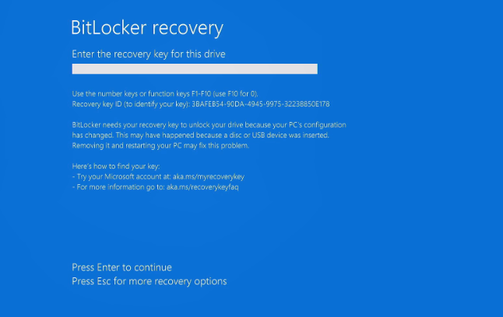 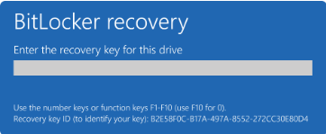

**Step-by-Step Instructions:**

1. **Access the Microsoft BitLocker Recovery Key Page**:
   * On his cellphone, Sebastian should open a web browser and go to the [Microsoft BitLocker Recovery Keys page](https://account.microsoft.com/devices/recoverykey)
2. **Sign In to Microsoft Account**:
   * Sebastian needs to sign in with the Microsoft account that was used to set up BitLocker on his computer.
3. **Locate the Recovery Key**:
   * Once signed in, he should see a list of devices associated with his account. He needs to find the device that is prompting for the BitLocker recovery key.
   * The recovery key ID displayed on the blue screen can help identify the correct key. Sebastian should note the first 8 digits of the recovery key ID shown on the blue screen.
4. **Retrieve the Recovery Key**:
   * After identifying the correct device, Sebastian should click on it to view the recovery key.
   * The 48-digit BitLocker recovery key will be displayed. He should carefully enter this key on the blue screen prompt on his computer.
5. **Additional Options**:
   * If Sebastian cannot find the recovery key in his Microsoft account, he should check other possible locations where the key might be stored:
     + **Printed Copy**: Look for a printed copy of the recovery key.
     + **USB Drive**: Check if the recovery key was saved to a USB drive.
     + **Active Directory**: If the device is part of a domain, contact the system administrator to retrieve the recovery key from Active Directory.
6. **Follow-Up Actions**:
   * Once the computer is unlocked, Sebastian should back up important data immediately.
   * It is also advisable to save the BitLocker recovery key in a secure location to avoid future issues.